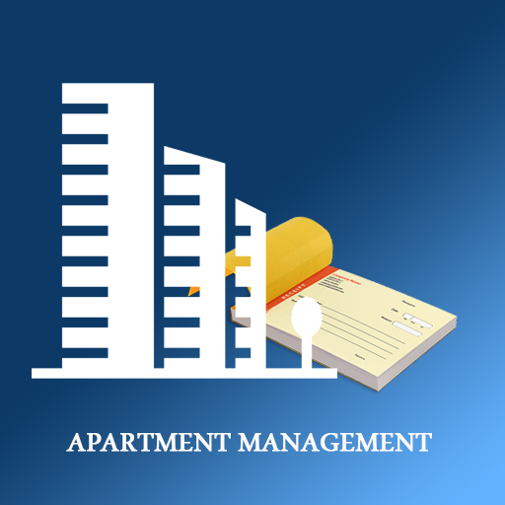***Project Department scheduler***

# Project definition

As students at the Fontys we, Alpay, Jan, Kassiia and Jarno are going to develop a solution for a department management. We all will contribute to the creation of the expected application, by dividing our group and assigning everyone a unique role. First week we going to analyse the problems and find the relevant solutions that will improve the structure of the tasks. We will discuss our strengths and weaknesses to optimise the workflow at maximum. Next weeks we will make the program using c# and other programming languages and develop a properly functioning interface. In the last week, we going to make a demonstrate our work, how we made it and how it is supposed to be worked with. We hope by the end of the assignment, to come up with a great outcome for the business.

# Project background

In this file we going to describe our project plan for our clients “the students” and the department management. Inside this department the tasks are not well divide and this causes frustrations

*Group leading*

As it is our second project, we are looking forward to enlarging our knowledge about ICT and our experience in practicing soft skills such as teamwork, communication skills and organisation.

# 

# Problem definition

As we analysed the problems of the student apartment, we have noticed a few problems inside the department. One of those problems is that the structure between the students, students don’t do their tasks that causes problems inside the department. Students are expected to do some tasks during the week so everyone does their part. Besides that, contemporary technology is barely used.

Problems:

* Deep clean kitchen
* Deep clean bathroom/toilet
* Takeout the trash
* Missing grocery products
* Forgetting laundry in the washing machine
* Irritated students

# Project goal

Nonetheless, our project goal is to achieve a simple useable system that can be used by the students and the department managers. The collaboration should be improved between the students and everyone have to do their tasks.

We will develop an application for the students and department, with which they should be able to check their tasks when they finished it. When someone doesn’t do their tasks, this will be shown on the application and there will be a punishment for it.

In addition, we will mainly focus only on the development for better communication and collaboration between the students.

We are going to use different types of code languages. These are c#, windows form app, git and SQL. We Have in total 3 weeks to succeed this project.

Tasks, you can choose your task until there are no tasks anymore, the quicker you are the more tasks there are open.